**2016 – Stock Data Analysis**

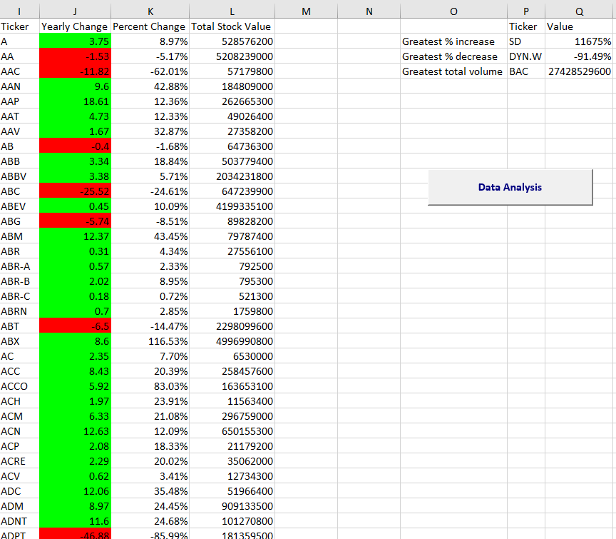

**2015 – Stock Data Analysis**

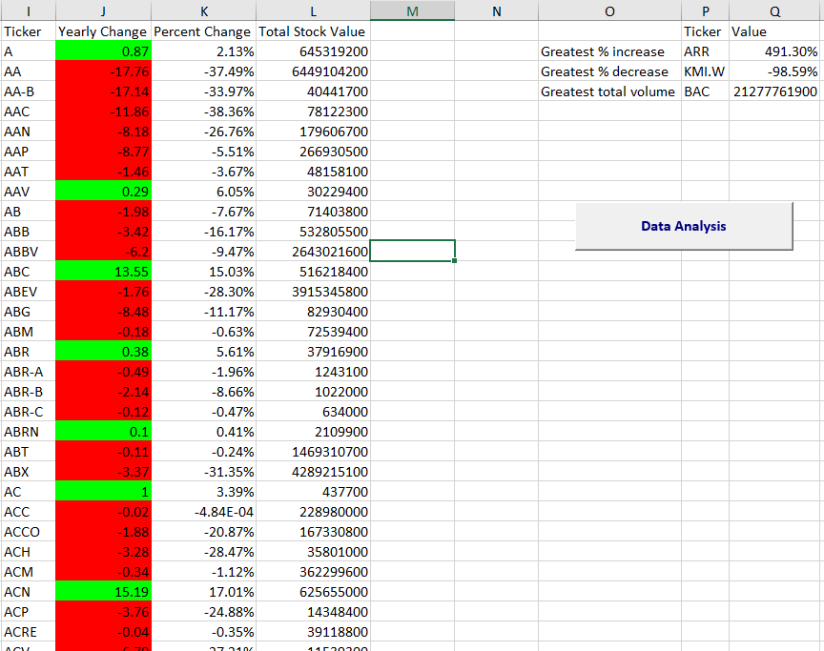

**2014 – Stock Data Analysis**

